the ncML specs group
ncML-G
and
ncML-G_{ML} Ver. 0.3.1
An extension of ncML for enabling interoperability with GIS
SCHEMA DOCUMENTATION


When netCDF meets GIS Coomunity

Editor: Stefano Nativi

January 2005

UNIDATA / UCAR
University of Florence
Italian National Research Council /IMAA

Send comments to nativi@ucar.edu ( nativi@imaa.cnr.it )

INDEX
INDEX 2
XML Schemas documentation 3
Documentation of geoCoordinateSystem schema version 0.3.1 3
geoCoordinateSystem schema source 16
Documentation of coverageGeoCoordSystem schema version 0.3.1 18
coverageGeoCoordSystem schema source 44
References 46

Objectives
The main object of the GIS extension model for ncML is to facilitate the interoperability between the Earth Sciences and the GIS Communities.
Such interoperability is essential to support interoperability: between the Earth Sciences Community and the Society.
The present extension introduces a set of optional elements which are useful to describe a netCDF dataset according to geo-spatial models introduced by international committee for standardization.
These elements are based on the following international standardization initiatives: OGC OpenGIS and ISO TC211.
The ncML-G expected result is to ease the import of netCDF dataset from GIS tools.
The ncML-G_{ML} schema was conceived to explicitly formalize the introduced solution to harmonize Earth Sciences and GIS data models (i.e. ncML-G). NcML-G_{ML} must consist of two parts (or views):
– a multidimesional array model for ES community realm;
– a feature/coverage model for GIS community realm;

Overview
See the separated documentation

XML Schemas documentation

Documentation of geoCoordinateSystem schema version 0.3.1
Schema geoCoordinateSystem.xsd version 0.3.1

Elements | Complex types
geoCoordinateSystem | _DatasetGeoDomainExtent
geoRefCoordinateSystem | _DatasetGeoDomainLocation
spatialExtent | _GeoCoordinateSystemType
temporalExtent | _GeoRefCoordinateSystemType
verticalExtent | _TemporalExtent
 | _VerticalExtent

schema location: | http://www.unidata.ucar.edu/schemas/netcdf-cs.xsd
targetNamespace: | http://www.ucar.edu/schemas/netcdf

Elements | Complex types
coordinateAxis | CoordinateAxisBoundaryType
coordinateAxisBoundary | CoordinateAxisType
coordinateSystem | CoordinateSystemType
coordinateTransform | CoordinateTransformType
 | NetcdfType (r)
 | VariableType (r)

schema location: | http://www.unidata.ucar.edu/schemas/netcdf.xsd
targetNamespace: | http://www.ucar.edu/schemas/netcdf

Elements | Complex types
attribute | AttributeType
dimension | DimensionType
netcdf | NetcdfType
values | ValuesType
variable | VariableType

element geoCoordinateSystem
diagram | 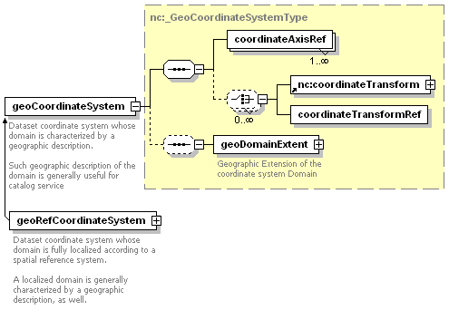
namespace | http://www.ucar.edu/schemas/netcdf
type | nc:_GeoCoordinateSystemType
children | coordinateAxisRef nc:coordinateTransform coordinateTransformRef geoDomainExtent
attributes
  Name | Type | Use | Default | Fixed | Annotation
  name | xsd:token | required
annotation
  documentation | Dataset coordinate system whose domain is characterized by a geographic description.  Such geographic description of the domain is generally useful for catalog service
source | <xsd:element name="geoCoordinateSystem" type="nc:_GeoCoordinateSystemType" substitutionGroup="nc:coordinateSystem">  <xsd:annotation>  <xsd:documentation>Dataset coordinate system whose domain is characterized by a geographic description.  Such geographic description of the domain is generally useful for catalog service</xsd:documentation>  </xsd:annotation>  </xsd:element>

element geoRefCoordinateSystem
diagram | 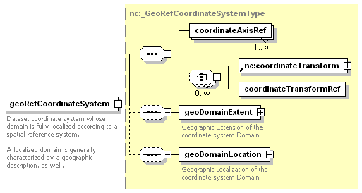
namespace | http://www.ucar.edu/schemas/netcdf
type | nc:_GeoRefCoordinateSystemType
children | coordinateAxisRef nc:coordinateTransform coordinateTransformRef geoDomainExtent geoDomainLocation
attributes
  Name | Type | Use | Default | Fixed | Annotation
  name | xsd:token | required
annotation
  documentation | Dataset coordinate system whose domain is fully localized according to a spatial reference system.  A localized domain is generally characterized by a geographic description, as well.
source | <xsd:element name="geoRefCoordinateSystem" type="nc:_GeoRefCoordinateSystemType" substitutionGroup="nc:geoCoordinateSystem">  <xsd:annotation>  <xsd:documentation>Dataset coordinate system whose domain is fully localized according to a spatial reference system.  A localized domain is generally characterized by a geographic description, as well.</xsd:documentation>  </xsd:annotation>  </xsd:element>

element spatialExtent
diagram | 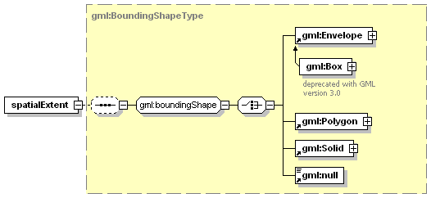
namespace | http://www.ucar.edu/schemas/netcdf
type | gml:BoundingShapeType
children | gml:Envelope gml:Polygon gml:Solid gml:null
used by
  complexType | _DatasetGeoDomainExtent
attributes
  Name | Type | Use | Default | Fixed | Annotation
  type | string |  |  | simple
  xlink:href | anyURI | optional
  xlink:role | anyURI | optional
  xlink:arcrole | anyURI | optional
  xlink:title | string | optional
  xlink:show | string | optional
  xlink:actuate | string | optional
  gml:remoteSchema | anyURI | optional
source | <xsd:element name="spatialExtent" type="gml:BoundingShapeType"/>

element temporalExtent
diagram | 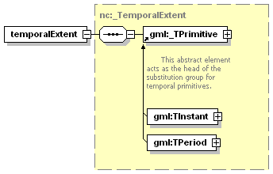
namespace | http://www.ucar.edu/schemas/netcdf
type | nc:_TemporalExtent
children | gml:_TPrimitive
used by
  complexType | _DatasetGeoDomainExtent
source | <xsd:element name="temporalExtent" type="nc:_TemporalExtent"/>

element verticalExtent
diagram | 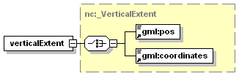
namespace | http://www.ucar.edu/schemas/netcdf
type | nc:_VerticalExtent
children | gml:pos gml:coordinates
used by
  complexType | _DatasetGeoDomainExtent
attributes
  Name | Type | Use | Default | Fixed | Annotation
  srsName | xsd:anyURI | optional
source | <xsd:element name="verticalExtent" type="nc:_VerticalExtent"/>

complexType _DatasetGeoDomainExtent
diagram | 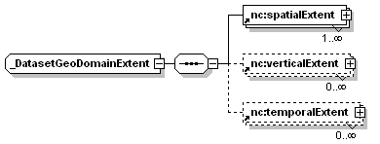
namespace | http://www.ucar.edu/schemas/netcdf
children | nc:spatialExtent nc:verticalExtent nc:temporalExtent
used by
  element | _GeoCoordinateSystemType/geoDomainExtent
attributes
  Name | Type | Use | Default | Fixed | Annotation
  description | xsd:string | optional
source | <xsd:complexType name="_DatasetGeoDomainExtent" abstract="false">  <xsd:sequence>  <xsd:element ref="nc:spatialExtent" maxOccurs="unbounded"/>  <xsd:element ref="nc:verticalExtent" minOccurs="0" maxOccurs="unbounded"/>  <xsd:element ref="nc:temporalExtent" minOccurs="0" maxOccurs="unbounded"/>  </xsd:sequence>  <xsd:attribute name="description" type="xsd:string" use="optional"/>  </xsd:complexType>

complexType _DatasetGeoDomainLocation
diagram | 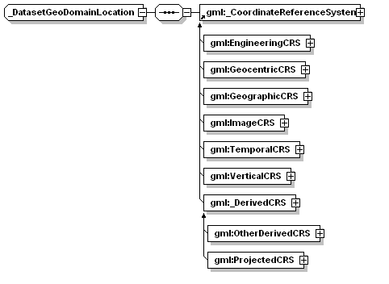
namespace | http://www.ucar.edu/schemas/netcdf
children | gml:_CoordinateReferenceSystem
used by
  element | _GeoRefCoordinateSystemType/geoDomainLocation
source | <xsd:complexType name="_DatasetGeoDomainLocation">  <xsd:sequence>  <xsd:element ref="gml:_CoordinateReferenceSystem"/>  </xsd:sequence>  </xsd:complexType>

complexType _GeoCoordinateSystemType
diagram | 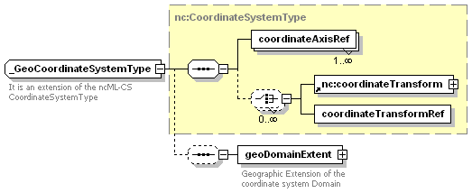
namespace | http://www.ucar.edu/schemas/netcdf
type | extension of nc:CoordinateSystemType
children | coordinateAxisRef nc:coordinateTransform coordinateTransformRef geoDomainExtent
used by
  element | geoCoordinateSystem
  complexType | _GeoRefCoordinateSystemType
attributes
  Name | Type | Use | Default | Fixed | Annotation
  name | xsd:token | required
annotation
  documentation | It is an extension of the ncML-CS CoordinateSystemType
source | <xsd:complexType name="_GeoCoordinateSystemType">  <xsd:annotation>  <xsd:documentation>It is an extension of the ncML-CS CoordinateSystemType</xsd:documentation>  </xsd:annotation>  <xsd:complexContent>  <xsd:extension base="nc:CoordinateSystemType">  <xsd:sequence minOccurs="0">  <xsd:element name="geoDomainExtent" type="nc:_DatasetGeoDomainExtent">  <xsd:annotation>  <xsd:documentation>Geographic Extension of the coordinate system Domain</xsd:documentation>  </xsd:annotation>  </xsd:element>  </xsd:sequence>  </xsd:extension>  </xsd:complexContent>  </xsd:complexType>

element _GeoCoordinateSystemType/geoDomainExtent
diagram | 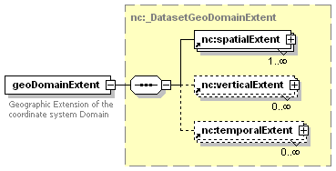
namespace | http://www.ucar.edu/schemas/netcdf
type | nc:_DatasetGeoDomainExtent
children | nc:spatialExtent nc:verticalExtent nc:temporalExtent
attributes
  Name | Type | Use | Default | Fixed | Annotation
  description | xsd:string | optional
annotation
  documentation | Geographic Extension of the coordinate system Domain
source | <xsd:element name="geoDomainExtent" type="nc:_DatasetGeoDomainExtent">  <xsd:annotation>  <xsd:documentation>Geographic Extension of the coordinate system Domain</xsd:documentation>  </xsd:annotation>  </xsd:element>

complexType _GeoRefCoordinateSystemType
diagram | 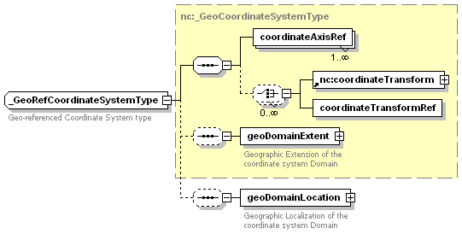
namespace | http://www.ucar.edu/schemas/netcdf
type | extension of nc:_GeoCoordinateSystemType
children | coordinateAxisRef nc:coordinateTransform coordinateTransformRef geoDomainExtent geoDomainLocation
used by
  element | geoRefCoordinateSystem
attributes
  Name | Type | Use | Default | Fixed | Annotation
  name | xsd:token | required
annotation
  documentation | Geo-referenced Coordinate System type
source | <xsd:complexType name="_GeoRefCoordinateSystemType">  <xsd:annotation>  <xsd:documentation>Geo-referenced Coordinate System type</xsd:documentation>  </xsd:annotation>  <xsd:complexContent>  <xsd:extension base="nc:_GeoCoordinateSystemType">  <xsd:sequence minOccurs="0">  <xsd:element name="geoDomainLocation" type="nc:_DatasetGeoDomainLocation">  <xsd:annotation>  <xsd:documentation>Geographic Localization of the coordinate system Domain</xsd:documentation>  </xsd:annotation>  </xsd:element>  </xsd:sequence>  </xsd:extension>  </xsd:complexContent>  </xsd:complexType>

element _GeoRefCoordinateSystemType/geoDomainLocation
diagram | 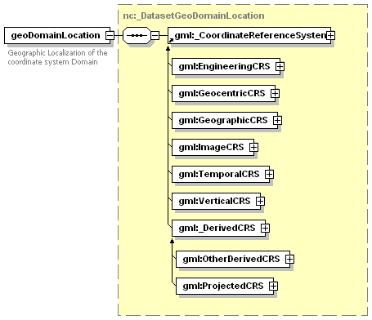
namespace | http://www.ucar.edu/schemas/netcdf
type | nc:_DatasetGeoDomainLocation
children | gml:_CoordinateReferenceSystem
annotation
  documentation | Geographic Localization of the coordinate system Domain
source | <xsd:element name="geoDomainLocation" type="nc:_DatasetGeoDomainLocation">  <xsd:annotation>  <xsd:documentation>Geographic Localization of the coordinate system Domain</xsd:documentation>  </xsd:annotation>  </xsd:element>

complexType _TemporalExtent
diagram | 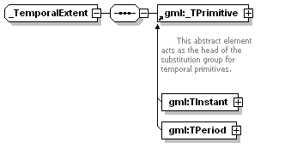
namespace | http://www.ucar.edu/schemas/netcdf
children | gml:_TPrimitive
used by
  element | temporalExtent
source | <xsd:complexType name="_TemporalExtent" abstract="false">  <xsd:sequence>  <xsd:element ref="gml:_TPrimitive"/>  </xsd:sequence>  </xsd:complexType>

complexType _VerticalExtent
diagram | 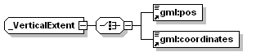
namespace | http://www.ucar.edu/schemas/netcdf
children | gml:pos gml:coordinates
used by
  element | vertical Extent
attributes
  Name | Type | Use | Default | Fixed | Annotation
  srsName | xsd:anyURI | optional
source | <xsd:complexType name="_VerticalExtent" abstract="false">  <xsd:choice>  <xsd:element ref="gml:pos"/>  <xsd:element ref="gml:coordinates"/>  </xsd:choice>  <xsd:attribute name="srsName" type="xsd:anyURI" use="optional"/>  </xsd:complexType>

element nc:coordinateAxis
diagram | 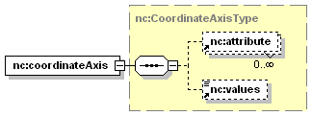
namespace | http://www.ucar.edu/schemas/netcdf
type | nc:CoordinateAxisType
children | nc:attribute nc:values
attributes
  Name | Type | Use | Default | Fixed | Annotation
  name | xsd:token | required
  shape | xsd:token | optional
  type | nc:DataType | required
  units | xsd:token | required
  axisType | nc:AxisType | optional
  positive | nc:PositiveValue | optional
  boundaryRef | xsd:token | optional
source | <xsd:element name="coordinateAxis" type="nc:CoordinateAxisType" substitutionGroup="nc:variable"/>

element nc:coordinateAxisBoundary
diagram | 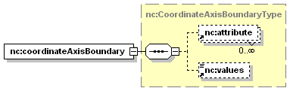
namespace | http://www.ucar.edu/schemas/netcdf
type | nc:CoordinateAxisBoundaryType
children | nc:attribute nc:values
attributes
  Name | Type | Use | Default | Fixed | Annotation
  name | xsd:token | required
  shape | xsd:token | optional
  type | nc:DataType | required
source | <xsd:element name="coordinateAxisBoundary" type="nc:CoordinateAxisBoundaryType" substitutionGroup="nc:variable"/>

element nc:coordinateSystem
diagram | 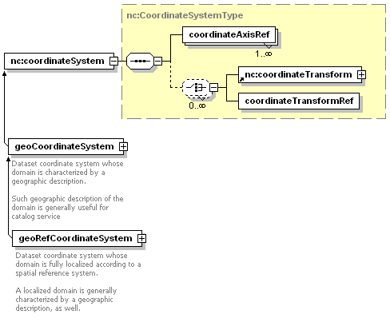
namespace | http://www.ucar.edu/schemas/netcdf
type | nc:CoordinateSystemType
children | coordinateAxisRef nc:coordinateTransform coordinateTransformRef
attributes
  Name | Type | Use | Default | Fixed | Annotation
  name | xsd:token | required
source | <xsd:element name="coordinateSystem" type="nc:CoordinateSystemType"/>

element nc:coordinateTransform
diagram | 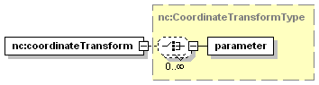
namespace | http://www.ucar.edu/schemas/netcdf
type | nc:CoordinateTransformType
children | parameter
used by
  complexType | nc:CoordinateSystemType
attributes
  Name | Type | Use | Default | Fixed | Annotation
  name | xsd:token | required
  authority | xsd:token | required
  transformType | nc:TransformType | optional
source | <xsd:element name="coordinateTransform" type="nc:CoordinateTransformType"/>

complexType nc:CoordinateAxisBoundaryType
diagram | 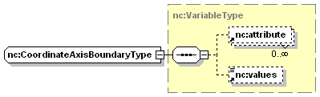
namespace | http://www.ucar.edu/schemas/netcdf
type | extension of nc:VariableType
children | nc:attribute nc:values
used by
  element | nc:coordinateAxisBoundary
attributes
  Name | Type | Use | Default | Fixed | Annotation
  name | xsd:token | required
  shape | xsd:token | optional
  type | nc:DataType | required
source | <xsd:complexType name="CoordinateAxisBoundaryType">  <xsd:complexContent>  <xsd:extension base="nc:VariableType"/>  </xsd:complexContent>  </xsd:complexType>

complexType nc:CoordinateAxisType
diagram | 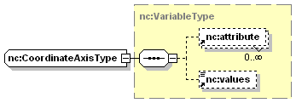
namespace | http://www.ucar.edu/schemas/netcdf
type | extension of nc:VariableType
children | nc:attribute nc:values
used by
  element | nc:coordinateAxis
attributes
  Name | Type | Use | Default | Fixed | Annotation
  name | xsd:token | required
  shape | xsd:token | optional
  type | nc:DataType | required
  units | xsd:token | required
  axisType | nc:AxisType | optional
  positive | nc:PositiveValue | optional
  boundaryRef | xsd:token | optional
source | <xsd:complexType name="CoordinateAxisType">  <xsd:complexContent>  <xsd:extension base="nc:VariableType">  <xsd:attribute name="units" type="xsd:token" use="required"/>  <xsd:attribute name="axisType" type="nc:AxisType" use="optional"/>  <xsd:attribute name="positive" type="nc:PositiveValue" use="optional"/>  <xsd:attribute name="boundaryRef" type="xsd:token" use="optional"/>  </xsd:extension>  </xsd:complexContent>  </xsd:complexType>

complexType nc:CoordinateSystemType
diagram | 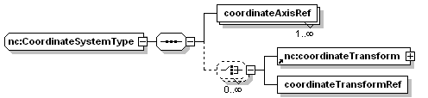
namespace | http://www.ucar.edu/schemas/netcdf
children | coordinateAxisRef nc:coordinateTransform coordinateTransformRef
used by
  element | nc:coordinateSystem
  complexType | _GeoCoordinateSystemType
attributes
  Name | Type | Use | Default | Fixed | Annotation
  name | xsd:token | required
source | <xsd:complexType name="CoordinateSystemType">  <xsd:sequence>  <xsd:element name="coordinateAxisRef" maxOccurs="unbounded">  <xsd:complexType>  <xsd:attribute name="ref" type="xsd:string"/>  </xsd:complexType>  </xsd:element>  <xsd:choice minOccurs="0" maxOccurs="unbounded">  <xsd:element ref="nc:coordinateTransform"/>  <xsd:element name="coordinateTransformRef">  <xsd:complexType>  <xsd:attribute name="ref" type="xsd:token"/>  </xsd:complexType>  </xsd:element>  </xsd:choice>  <!-- coordinate axis references -->  <!-- set of coordinateTransform or coordinateTransform references -->  </xsd:sequence>  <xsd:attribute name="name" type="xsd:token" use="required"/>  </xsd:complexType>

element nc:CoordinateSystemType/coordinateAxisRef
diagram
namespace | http://www.ucar.edu/schemas/netcdf
attributes
  Name | Type | Use | Default | Fixed | Annotation
  ref | xsd:string
source | <xsd:element name="coordinateAxisRef" maxOccurs="unbounded">  <xsd:complexType>  <xsd:attribute name="ref" type="xsd:string"/>  </xsd:complexType>  </xsd:element>

element nc:CoordinateSystemType/coordinateTransformRef
diagram
namespace | http://www.ucar.edu/schemas/netcdf
attributes
  Name | Type | Use | Default | Fixed | Annotation
  ref | xsd:token
source | <xsd:element name="coordinateTransformRef">  <xsd:complexType>  <xsd:attribute name="ref" type="xsd:token"/>  </xsd:complexType>  </xsd:element>

complexType nc:CoordinateTransformType
diagram | 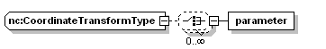
namespace | http://www.ucar.edu/schemas/netcdf
children | parameter
used by
  element | nc:coordinateTransform
attributes
  Name | Type | Use | Default | Fixed | Annotation
  name | xsd:token | required
  authority | xsd:token | required
  transformType | nc:TransformType | optional
source | <xsd:complexType name="CoordinateTransformType">  <xsd:choice minOccurs="0" maxOccurs="unbounded">  <xsd:element name="parameter" type="nc:AttributeType"/>  </xsd:choice>  <xsd:attribute name="name" type="xsd:token" use="required"/>  <xsd:attribute name="authority" type="xsd:token" use="required"/>  <xsd:attribute name="transformType" type="nc:TransformType" use="optional"/>  </xsd:complexType>

element nc:CoordinateTransformType/parameter
diagram
namespace | http://www.ucar.edu/schemas/netcdf
type | nc:AttributeType
attributes
  Name | Type | Use | Default | Fixed | Annotation
  name | xsd:token | required
  type | nc:DataType | required
  value | xsd:string | optional
  separator | xsd:string
source | <xsd:element name="parameter" type="nc:AttributeType"/>

redefinition of complexType NetcdfType
diagram | 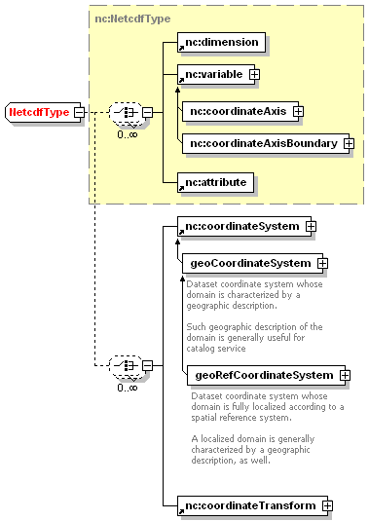
type | extension of nc:NetcdfType
children | nc:dimension nc:variable nc:attribute nc:coordinateSystem nc:coordinateTransform
used by
  element | nc:netcdf
attributes
  Name | Type | Use | Default | Fixed | Annotation
  id | xsd:token | optional
  uri | xsd:anyURI | optional
source | <xsd:complexType name="NetcdfType">  <xsd:complexContent>  <xsd:extension base="nc:NetcdfType">  <xsd:choice minOccurs="0" maxOccurs="unbounded">  <xsd:element ref="nc:coordinateSystem"/>  <xsd:element ref="nc:coordinateTransform"/>  </xsd:choice>  </xsd:extension>  </xsd:complexContent>  </xsd:complexType>

geoCoordinateSystem schema source
<?xml version="1.0" encoding="UTF-8" ?>
<!--
edited with XMLSPY v5 rel. 4 U (http://www.xmlspy.com) by Stefano Nativi (UCAR Unidata)
-->
<xsd:schema targetNamespace="http://www.ucar.edu/schemas/netcdf" xmlns:nc="http://www.ucar.edu/schemas/netcdf" xmlns:fgdc="http://www.fgdc.gov/metadata/standards" xmlns:gml="http://www.opengis.net/gml" xmlns:xsd="http://www.w3.org/2001/XMLSchema" elementFormDefault="qualified">
<xsd:annotation>
<xsd:documentation>
<appinfo source="urn:ncML:specification:schema-xsd:geoCoordinateSystem:v0.3.1">geoCoordinateSystem.xsd</appinfo>
<documentation xml:lang="en">Metadata for unreferenced or referenced geo coordinate systems characeterizing a ncML dataset. An extension to the ncML core metadata in order to formalise netCDF metadata useful for GIS interoperability NcML Group, editor S. Nativi Creation: Boulder, Aug 2003; Update: Florence, Dec 2004;</documentation>
</xsd:documentation>
</xsd:annotation>
<xsd:import namespace="http://www.ucar.edu/schemas/netcdf" schemaLocation="http://www.unidata.ucar.edu/schemas/netcdf-cs.xsd" />
<xsd:import namespace="http://www.opengis.net/gml" schemaLocation="C:\Nativi\Geomatics\STANDARDS\OpenGIS\GML NWIP\GML3\gml3.0\base\feature.xsd" />
<xsd:import namespace="http://www.opengis.net/gml" schemaLocation="C:\Nativi\Geomatics\STANDARDS\OpenGIS\GML NWIP\GML3\gml3.0\base\temporal.xsd" />
<xsd:import namespace="http://www.opengis.net/gml" schemaLocation="C:\Nativi\Geomatics\STANDARDS\OpenGIS\GML NWIP\GML3\gml3.0\base\coordinateReferenceSystems.xsd" />
<!--
====================== Elements ========================
-->
<xsd:element name="geoCoordinateSystem" type="nc:_GeoCoordinateSystemType" substitutionGroup="nc:coordinateSystem">
<xsd:annotation>
<xsd:documentation>Dataset coordinate system whose domain is characterized by a geographic description. Such geographic description of the domain is generally useful for catalog service</xsd:documentation>
</xsd:annotation>
</xsd:element>
<xsd:element name="geoRefCoordinateSystem" type="nc:_GeoRefCoordinateSystemType" substitutionGroup="nc:geoCoordinateSystem">
<xsd:annotation>
<xsd:documentation>Dataset coordinate system whose domain is fully localized according to a spatial reference system. A localized domain is generally characterized by a geographic description, as well.</xsd:documentation>
</xsd:annotation>
</xsd:element>
<!--
======================= Complex type =======================
-->
<xsd:complexType name="_GeoRefCoordinateSystemType">
<xsd:annotation>
<xsd:documentation>Geo-referenced Coordinate System type</xsd:documentation>
</xsd:annotation>
<xsd:complexContent>
<xsd:extension base="nc:_GeoCoordinateSystemType">
<xsd:sequence minOccurs="0">
<xsd:element name="geoDomainLocation" type="nc:_DatasetGeoDomainLocation">
<xsd:annotation>
<xsd:documentation>Geographic Localization of the coordinate system Domain</xsd:documentation>
</xsd:annotation>
</xsd:element>
</xsd:sequence>
</xsd:extension>
</xsd:complexContent>
</xsd:complexType>
<xsd:complexType name="_GeoCoordinateSystemType">
<xsd:annotation>
<xsd:documentation>It is an extension of the ncML-CS CoordinateSystemType</xsd:documentation>
</xsd:annotation>
<xsd:complexContent>
<xsd:extension base="nc:CoordinateSystemType">
<xsd:sequence minOccurs="0">
<xsd:element name="geoDomainExtent" type="nc:_DatasetGeoDomainExtent">
<xsd:annotation>
<xsd:documentation>Geographic Extension of the coordinate system Domain</xsd:documentation>
</xsd:annotation>
</xsd:element>
</xsd:sequence>
</xsd:extension>
</xsd:complexContent>
</xsd:complexType>
<xsd:complexType name="_DatasetGeoDomainExtent" abstract="false">
<xsd:sequence>
<xsd:element ref="nc:spatialExtent" maxOccurs="unbounded" />
<xsd:element ref="nc:verticalExtent" minOccurs="0" maxOccurs="unbounded" />
<xsd:element ref="nc:temporalExtent" minOccurs="0" maxOccurs="unbounded" />
</xsd:sequence>
<xsd:attribute name="description" type="xsd:string" use="optional" />
</xsd:complexType>
<xsd:complexType name="_DatasetGeoDomainLocation">
<xsd:sequence>
<xsd:element ref="gml:_CoordinateReferenceSystem" />
</xsd:sequence>
</xsd:complexType>
<xsd:complexType name="_TemporalExtent" abstract="false">
<xsd:sequence>
<xsd:element ref="gml:_TPrimitive" />
</xsd:sequence>
</xsd:complexType>
<xsd:complexType name="_VerticalExtent" abstract="false">
<xsd:choice>
<xsd:element ref="gml:pos" />
<xsd:element ref="gml:coordinates" />
</xsd:choice>
<xsd:attribute name="srsName" type="xsd:anyURI" use="optional" />
</xsd:complexType>
<!--
======================= GML based elements =======================
-->
<xsd:element name="verticalExtent" type="nc:_VerticalExtent" />
<xsd:element name="temporalExtent" type="nc:_TemporalExtent" />
<xsd:element name="spatialExtent" type="gml:BoundingShapeType" />
</xsd:schema>

Documentation of coverageGeoCoordSystem schema version 0.3.1
Schema coverageGeoCoordSystem.xsd

schema location: | C:\Nativi\PAPERI\GIM\schemas\coverageGeoCoordSystem.xsd
targetNamespace: | http://www.ucar.edu/schemas/netcdf

Elements | Complex types
coverageGeoCoordSystem | _CoverageGeoCoordSystem
coverageGeoRefCoordSystem | _CoverageGeoRefCoordSystem
grid | _GridCoverageType
gridCoverage | _RectifiedGridCoverageType
netcdfCoverages
rangeInfo
rectifiedGrid
rectifiedGridCoverage
variableRef

schema location: | C:\Nativi\PAPERI\GIM\schemas\GeoCoordinateSystem.xsd
targetNamespace: | http://www.ucar.edu/schemas/netcdf

Elements | Complex types
geoCoordinateSystem | _DatasetGeoDomainExtent
geoRefCoordinateSystem | _DatasetGeoDomainLocation
spatialExtent | _GeoCoordinateSystemType
temporalExtent | _GeoRefCoordinateSystemType
verticalExtent | _TemporalExtent
 | _VerticalExtent

element coverageGeoCoordSystem
diagram | 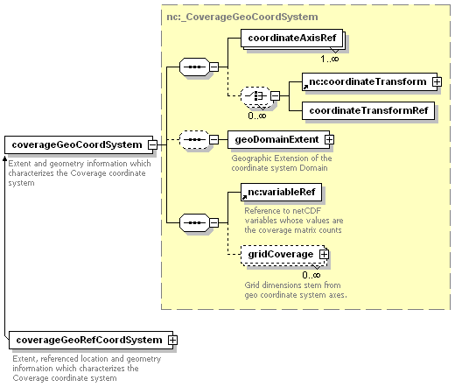
namespace | http://www.ucar.edu/schemas/netcdf
type | nc:_CoverageGeoCoordSystem
children | coordinateAxisRef nc:coordinateTransform coordinateTransformRef geoDomainExtent nc:variableRef gridCoverage
used by
  element | netcdfCoverages
attributes
  Name | Type | Use | Default | Fixed | Annotation
  name | xsd:token | required
annotation
  documentation | Extent and geometry information which characterizes the Coverage coordinate system

element coverageGeoRefCoordSystem
diagram | 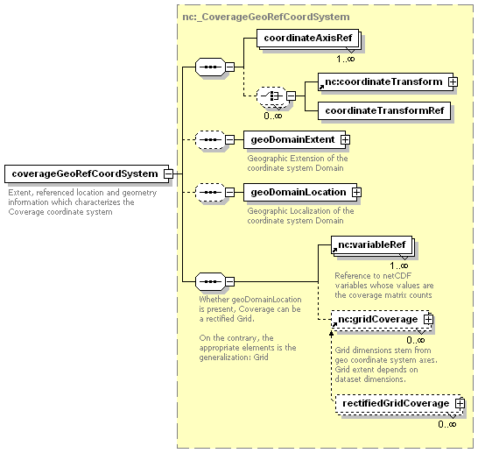
namespace | http://www.ucar.edu/schemas/netcdf
type | nc:_CoverageGeoRefCoordSystem
children | coordinateAxisRef nc:coordinateTransform coordinateTransformRef geoDomainExtent geoDomainLocation nc:variableRef nc:gridCoverage
attributes
  Name | Type | Use | Default | Fixed | Annotation
  name | xsd:token | required
annotation
  documentation | Extent, referenced location and geometry information which characterizes the Coverage coordinate system

element grid
diagram | 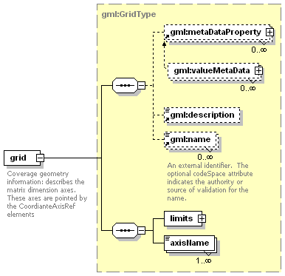
namespace | http://www.ucar.edu/schemas/netcdf
type | gml:GridType
children | gml:metaDataProperty gml:description gml:name limits axisName
used by
  complexType | _GridCoverageType
attributes
  Name | Type | Use | Default | Fixed | Annotation
  gml:id | ID | optional
  gid | string | optional
    documentation | For backward compatibility with GML2. This identifer is superceded by gml:id inherited from AbstractGMLType.
  srsName | anyURI | optional
  dimension | positiveInteger | required
annotation
  documentation | Coverage geometry information: describes the matrix dimension axes. These axes are pointed by the CoordianteAxisRef elements

element gridCoverage
diagram | 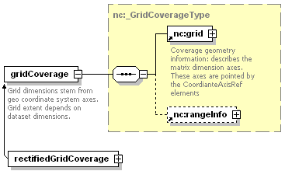
namespace | http://www.ucar.edu/schemas/netcdf
type | nc:_GridCoverageType
children | nc:grid nc:rangeInfo
used by
  complexType | _CoverageGeoRefCoordSystem
annotation
  documentation | Grid dimensions stem from geo coordinate system axes. Grid extent depends on dataset dimensions.

element netcdfCoverages
diagram | 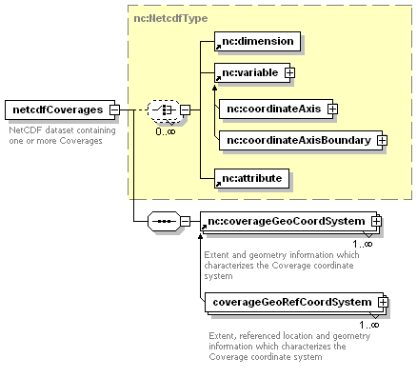
namespace | http://www.ucar.edu/schemas/netcdf
type | extension of nc:NetcdfType
children | nc:dimension nc:variable nc:attribute nc:coverageGeoCoordSystem
attributes
  Name | Type | Use | Default | Fixed | Annotation
  id | xsd:token | optional
  uri | xsd:anyURI | optional
annotation
  documentation | NetCDF dataset containing one or more Coverages

element rangeInfo
diagram | 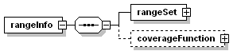
namespace | http://www.ucar.edu/schemas/netcdf
children | rangeSet coverageFunction
used by
  complexTypes | _GridCoverageType _RectifiedGridCoverageType

element rangeInfo/rangeSet
diagram | 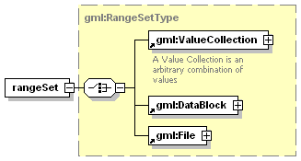
namespace | http://www.ucar.edu/schemas/netcdf
type | gml:RangeSetType
children | gml:ValueCollection gml:DataBlock gml:File

element rangeInfo/coverageFunction
diagram | 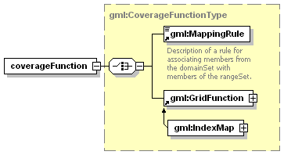
namespace | http://www.ucar.edu/schemas/netcdf
type | gml:CoverageFunctionType
children | gml:MappingRule gml:GridFunction

element rectifiedGrid
diagram | 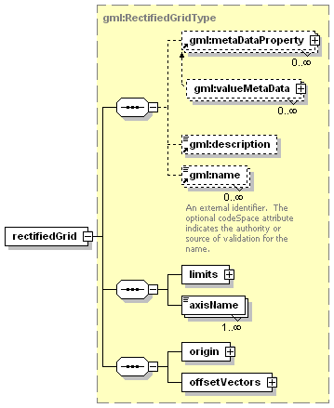
namespace | http://www.ucar.edu/schemas/netcdf
type | gml:RectifiedGridType
children | gml:metaDataProperty gml:description gml:name limits axisName origin offsetVectors
used by
  complexType | _RectifiedGridCoverageType
attributes
  Name | Type | Use | Default | Fixed | Annotation
  gml:id | ID | optional
  gid | string | optional
    documentation | For backward compatibility with GML2. This identifer is superceded by gml:id inherited from AbstractGMLType.
  srsName | anyURI | optional
  dimension | positiveInteger | required

element rectifiedGridCoverage
diagram | 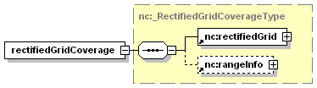
namespace | http://www.ucar.edu/schemas/netcdf
type | nc:_RectifiedGridCoverageType
children | nc:rectifiedGrid nc:rangeInfo

element variableRef
diagram | 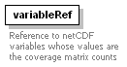
namespace | http://www.ucar.edu/schemas/netcdf
used by
  complexTypes | _CoverageGeoCoordSystem _CoverageGeoRefCoordSystem
attributes
  Name | Type | Use | Default | Fixed | Annotation
  ref | xsd:string
annotation
  documentation | Reference to netCDF variables whose values are the coverage matrix counts

complexType _CoverageGeoCoordSystem
diagram | 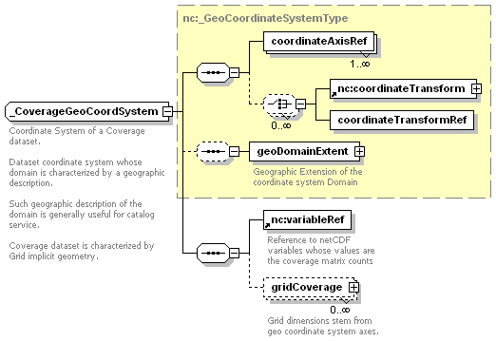
namespace | http://www.ucar.edu/schemas/netcdf
type | extension of nc:_GeoCoordinateSystemType
children | coordinateAxisRef nc:coordinateTransform coordinateTransformRef geoDomainExtent nc:variableRef gridCoverage
used by
  element | coverageGeoCoordSystem
attributes
  Name | Type | Use | Default | Fixed | Annotation
  name | xsd:token | required
annotation
  documentation | Coordinate System of a Coverage dataset.  Dataset coordinate system whose domain is characterized by a geographic description.  Such geographic description of the domain is generally useful for catalog service.  Coverage dataset is characterized by Grid implicit geometry.

element _CoverageGeoCoordSystem/gridCoverage
diagram | 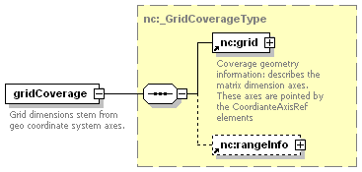
namespace | http://www.ucar.edu/schemas/netcdf
type | nc:_GridCoverageType
children | nc:grid nc:rangeInfo
annotation
  documentation | Grid dimensions stem from geo coordinate system axes.

complexType _CoverageGeoRefCoordSystem
diagram | 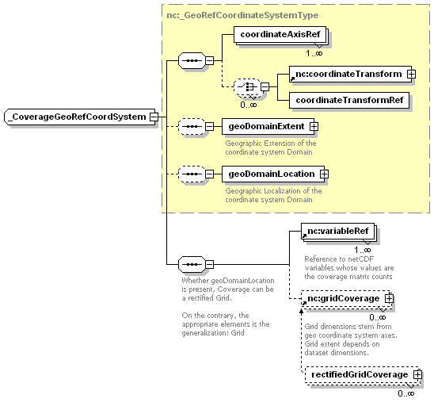
namespace | http://www.ucar.edu/schemas/netcdf
type | extension of nc:_GeoRefCoordinateSystemType
children | coordinateAxisRef nc:coordinateTransform coordinateTransformRef geoDomainExtent geoDomainLocation nc:variableRef nc:gridCoverage
used by
  element | coverageGeoRefCoordSystem
attributes
  Name | Type | Use | Default | Fixed | Annotation
  name | xsd:token | required

complexType _GridCoverageType
diagram | 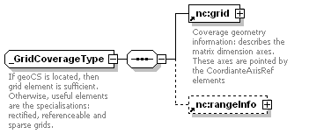
namespace | http://www.ucar.edu/schemas/netcdf
children | nc:grid nc:rangeInfo
used by
  elements | gridCoverage _CoverageGeoCoordSystem/gridCoverage
annotation
  documentation | If geoCS is located, then grid element is sufficient. Otherwise, useful elements are the specialisations: rectified, referenceable and sparse grids.

complexType _RectifiedGridCoverageType
diagram | 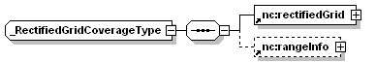
namespace | http://www.ucar.edu/schemas/netcdf
children | nc:rectifiedGrid nc:rangeInfo
used by
  element | rectifiedGridCoverage

element nc:geoCoordinateSystem
diagram | 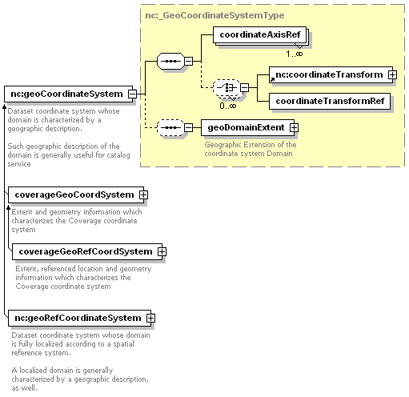
namespace | http://www.ucar.edu/schemas/netcdf
type | nc:_GeoCoordinateSystemType
children | coordinateAxisRef nc:coordinateTransform coordinateTransformRef geoDomainExtent
attributes
  Name | Type | Use | Default | Fixed | Annotation
  name | xsd:token | required
annotation
  documentation | Dataset coordinate system whose domain is characterized by a geographic description.  Such geographic description of the domain is generally useful for catalog service

element gml:_ImplicitGeometry
diagram | 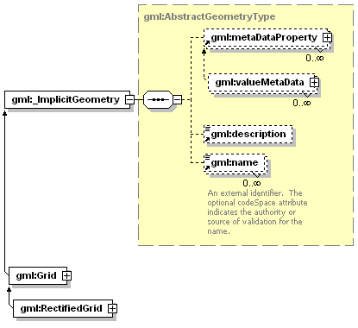
namespace | http://www.opengis.net/gml
type | gml:AbstractGeometryType
children | gml:metaDataProperty gml:description gml:name
attributes
  Name | Type | Use | Default | Fixed | Annotation
  gml:id | ID | optional
  gid | string | optional
    documentation | For backward compatibility with GML2. This identifer is superceded by gml:id inherited from AbstractGMLType.
  srsName | anyURI | optional

element gml:Grid
diagram | 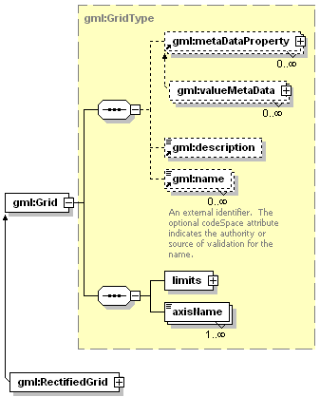
namespace | http://www.opengis.net/gml
type | gml:GridType
children | gml:metaDataProperty gml:description gml:name limits axisName
used by
  complexType | gml:GridDomainType
attributes
  Name | Type | Use | Default | Fixed | Annotation
  gml:id | ID | optional
  gid | string | optional
    documentation | For backward compatibility with GML2. This identifer is superceded by gml:id inherited from AbstractGMLType.
  srsName | anyURI | optional
  dimension | positiveInteger | required

element gml:RectifiedGrid
diagram | 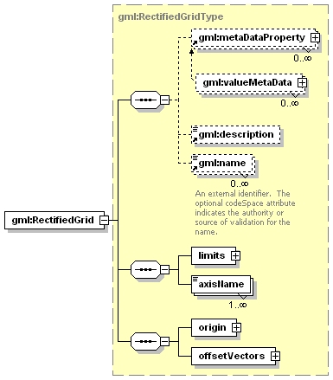
namespace | http://www.opengis.net/gml
type | gml:RectifiedGridType
children | gml:metaDataProperty gml:description gml:name limits axisName origin offsetVectors
used by
  complexType | gml:RectifiedGridDomainType
attributes
  Name | Type | Use | Default | Fixed | Annotation
  gml:id | ID | optional
  gid | string | optional
    documentation | For backward compatibility with GML2. This identifer is superceded by gml:id inherited from AbstractGMLType.
  srsName | anyURI | optional
  dimension | positiveInteger | required

complexType gml:GridEnvelopeType
diagram | 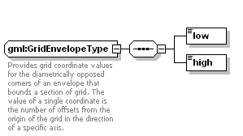
namespace | http://www.opengis.net/gml
children | low high
used by
  element | gml:GridLimitsType/GridEnvelope
annotation
  documentation | Provides grid coordinate values for the diametrically opposed corners of an envelope that bounds a section of grid. The value of a single coordinate is the number of offsets from the origin of the grid in the direction of a specific axis.

element gml:GridEnvelopeType/low
diagram
namespace | http://www.opengis.net/gml
type | gml:integerList

element gml:GridEnvelopeType/high
diagram
namespace | http://www.opengis.net/gml
type | gml:integerList

complexType gml:GridLimitsType
diagram
namespace | http://www.opengis.net/gml
children | GridEnvelope
used by
  element | gml:GridType/limits

element gml:GridLimitsType/GridEnvelope
diagram | 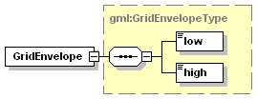
namespace | http://www.opengis.net/gml
type | gml:GridEnvelopeType
children | low high

complexType gml:GridType
diagram | 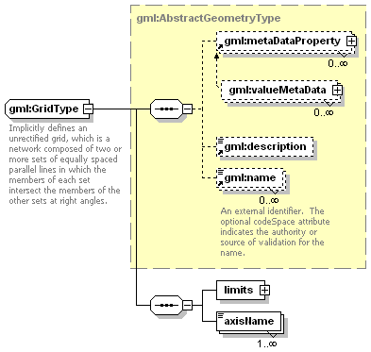
namespace | http://www.opengis.net/gml
type | extension of gml:AbstractGeometryType
children | gml:metaDataProperty gml:description gml:name limits axisName
used by
  elements | gml:Grid grid
  complexType | gml:RectifiedGridType
attributes
  Name | Type | Use | Default | Fixed | Annotation
  gml:id | ID | optional
  gid | string | optional
    documentation | For backward compatibility with GML2. This identifer is superceded by gml:id inherited from AbstractGMLType.
  srsName | anyURI | optional
  dimension | positiveInteger | required
annotation
  documentation | Implicitly defines an unrectified grid, which is a network composed of two or more sets of equally spaced parallel lines in which the members of each set intersect the members of the other sets at right angles.

element gml:GridType/limits
diagram | 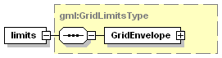
namespace | http://www.opengis.net/gml
type | gml:GridLimitsType
children | GridEnvelope

element gml:GridType/axisName
diagram
namespace | http://www.opengis.net/gml
type | xsd:string

complexType gml:RectifiedGridType
diagram | 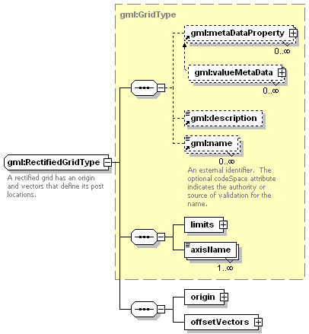
namespace | http://www.opengis.net/gml
type | extension of gml:GridType
children | gml:metaDataProperty gml:description gml:name limits axisName origin offsetVectors
used by
  elements | gml:RectifiedGrid rectifiedGrid
attributes
  Name | Type | Use | Default | Fixed | Annotation
  gml:id | ID | optional
  gid | string | optional
    documentation | For backward compatibility with GML2. This identifer is superceded by gml:id inherited from AbstractGMLType.
  srsName | anyURI | optional
  dimension | positiveInteger | required
annotation
  documentation | A rectified grid has an origin and vectors that define its post locations.

element gml:RectifiedGridType/origin
diagram | 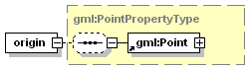
namespace | http://www.opengis.net/gml
type | gml:PointPropertyType
children | gml:Point
attributes
  Name | Type | Use | Default | Fixed | Annotation
  type | string |  |  | simple
  xlink:href | anyURI | optional
  xlink:role | anyURI | optional
  xlink:arcrole | anyURI | optional
  xlink:title | string | optional
  xlink:show | string | optional
  xlink:actuate | string | optional
  gml:remoteSchema | anyURI | optional

element gml:RectifiedGridType/offsetVectors
diagram | 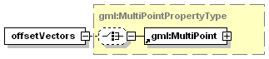
namespace | http://www.opengis.net/gml
type | gml:MultiPointPropertyType
children | gml:MultiPoint
attributes
  Name | Type | Use | Default | Fixed | Annotation
  type | string |  |  | simple
  xlink:href | anyURI | optional
  xlink:role | anyURI | optional
  xlink:arcrole | anyURI | optional
  xlink:title | string | optional
  xlink:show | string | optional
  xlink:actuate | string | optional
  gml:remoteSchema | anyURI | optional

element gml:_Coverage
diagram | 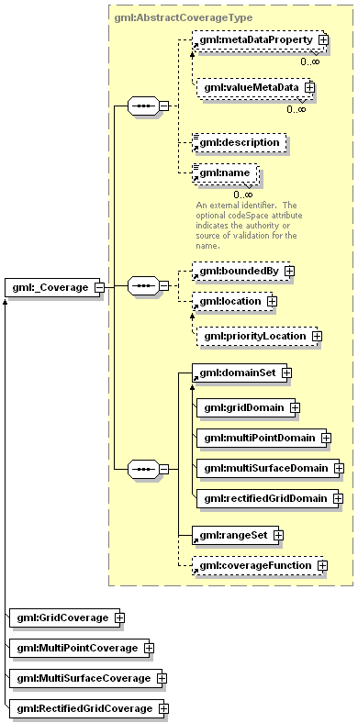
namespace | http://www.opengis.net/gml
type | gml:AbstractCoverageType
children | gml:metaDataProperty gml:description gml:name gml:boundedBy gml:location gml:domainSet gml:rangeSet gml:coverageFunction
attributes
  Name | Type | Use | Default | Fixed | Annotation
  gml:id | ID | optional
  fid | string
    appInfo | deprecated
    documentation | deprecated in GML version 3.0
  dimension | positiveInteger | optional

element gml:coverageFunction
diagram | 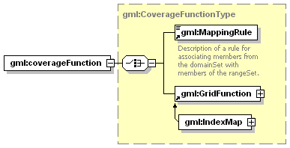
namespace | http://www.opengis.net/gml
type | gml:CoverageFunctionType
children | gml:MappingRule gml:GridFunction
used by
  complexTypes | gml:AbstractCoverageType gml:GridCoverageType gml:MultiPointCoverageType gml:MultiSurfaceCoverageType gml:RectifiedGridCoverageType

element gml:DataBlock
diagram | 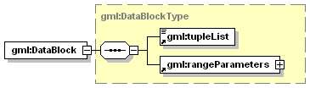
namespace | http://www.opengis.net/gml
type | gml:DataBlockType
children | gml:tupleList gml:rangeParameters
used by
  complexType | gml:RangeSetType

element gml:domainSet
namespace | http://www.opengis.net/gml
type | gml:DomainSetType
children | gml:_Geometry gml:_TObject gml:_Feature
used by
  complexType | gml:AbstractCoverageType
attributes
  Name | Type | Use | Default | Fixed | Annotation
  type | string |  |  | simple
  xlink:href | anyURI | optional
  xlink:role | anyURI | optional
  xlink:arcrole | anyURI | optional
  xlink:title | string | optional
  xlink:show | string | optional
  xlink:actuate | string | optional
  gml:remoteSchema | anyURI | optional

element gml:File
diagram | 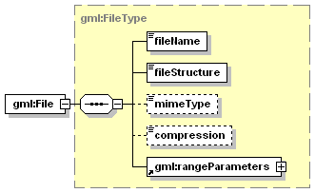
namespace | http://www.opengis.net/gml
type | gml:FileType
children | fileName fileStructure mimeType compression gml:rangeParameters
used by
  complexType | gml:RangeSetType

element gml:GridCoverage
diagram | 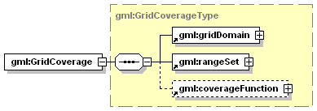
namespace | http://www.opengis.net/gml
type | gml:GridCoverageType
children | gml:gridDomain gml:rangeSet gml:coverageFunction
attributes
  Name | Type | Use | Default | Fixed | Annotation
  gml:id | ID | optional
  fid | string
    appInfo | deprecated
    documentation | deprecated in GML version 3.0
  dimension | positiveInteger | required

element gml:gridDomain
diagram | 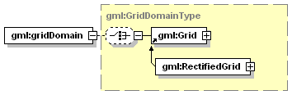
namespace | http://www.opengis.net/gml
type | gml:GridDomainType
children | gml:Grid
used by
  complexType | gml:GridCoverageType
attributes
  Name | Type | Use | Default | Fixed | Annotation
  type | string |  |  | simple
  xlink:href | anyURI | optional
  xlink:role | anyURI | optional
  xlink:arcrole | anyURI | optional
  xlink:title | string | optional
  xlink:show | string | optional
  xlink:actuate | string | optional
  gml:remoteSchema | anyURI | optional

element gml:GridFunction
diagram | 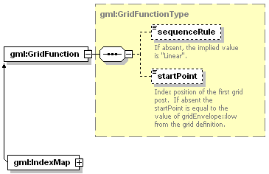
namespace | http://www.opengis.net/gml
type | gml:GridFunctionType
children | sequenceRule startPoint
used by
  complexType | gml:CoverageFunctionType

element gml:IndexMap
diagram | 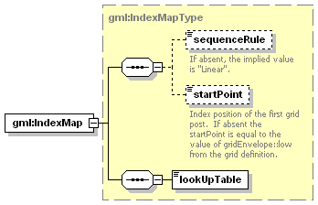
namespace | http://www.opengis.net/gml
type | gml:IndexMapType
children | sequenceRule startPoint lookUpTable

element gml:MappingRule
diagram | 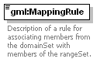
namespace | http://www.opengis.net/gml
type | gml:StringOrRefType
used by
  complexType | gml:CoverageFunctionType
attributes
  Name | Type | Use | Default | Fixed | Annotation
  gml:id | ID | optional
  type | string |  |  | simple
  xlink:href | anyURI | optional
  xlink:role | anyURI | optional
  xlink:arcrole | anyURI | optional
  xlink:title | string | optional
  xlink:show | string | optional
  xlink:actuate | string | optional
  gml:remoteSchema | anyURI | optional
annotation
  documentation | Description of a rule for associating members from the domainSet with members of the rangeSet.

element gml:MultiPointCoverage
diagram | 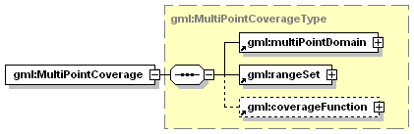
namespace | http://www.opengis.net/gml
type | gml:MultiPointCoverageType
children | gml:multiPointDomain gml:rangeSet gml:coverageFunction
attributes
  Name | Type | Use | Default | Fixed | Annotation
  gml:id | ID | optional
  fid | string
    appInfo | deprecated
    documentation | deprecated in GML version 3.0
  dimension | positiveInteger | required

element gml:multiPointDomain
diagram | 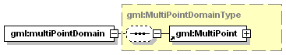
namespace | http://www.opengis.net/gml
type | gml:MultiPointDomainType
children | gml:MultiPoint
used by
  complexType | gml:MultiPointCoverageType
attributes
  Name | Type | Use | Default | Fixed | Annotation
  type | string |  |  | simple
  xlink:href | anyURI | optional
  xlink:role | anyURI | optional
  xlink:arcrole | anyURI | optional
  xlink:title | string | optional
  xlink:show | string | optional
  xlink:actuate | string | optional
  gml:remoteSchema | anyURI | optional

element gml:MultiSurfaceCoverage
diagram | 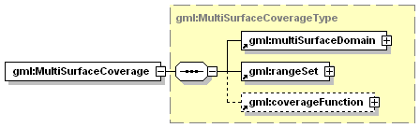
namespace | http://www.opengis.net/gml
type | gml:MultiSurfaceCoverageType
children | gml:multiSurfaceDomain gml:rangeSet gml:coverageFunction
attributes
  Name | Type | Use | Default | Fixed | Annotation
  gml:id | ID | optional
  fid | string
    appInfo | deprecated
    documentation | deprecated in GML version 3.0
  dimension | positiveInteger | required

element gml:multiSurfaceDomain
diagram | 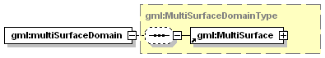
namespace | http://www.opengis.net/gml
type | gml:MultiSurfaceDomainType
children | gml:MultiSurface
used by
  complexType | gml:MultiSurfaceCoverageType
attributes
  Name | Type | Use | Default | Fixed | Annotation
  type | string |  |  | simple
  xlink:href | anyURI | optional
  xlink:role | anyURI | optional
  xlink:arcrole | anyURI | optional
  xlink:title | string | optional
  xlink:show | string | optional
  xlink:actuate | string | optional
  gml:remoteSchema | anyURI | optional

element gml:rangeParameters
diagram | 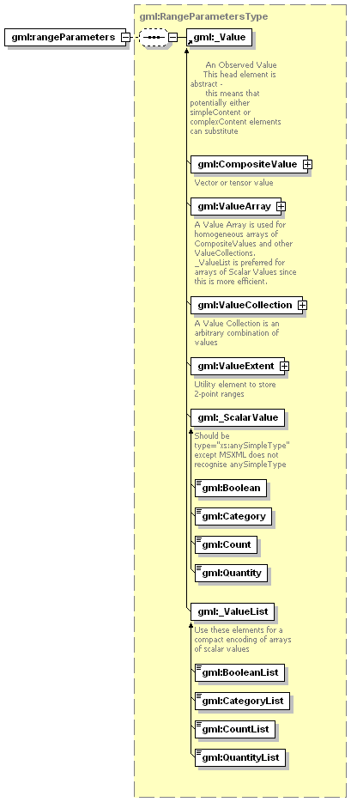
namespace | http://www.opengis.net/gml
type | gml:RangeParametersType
children | gml:_Value
used by
  complexTypes | gml:DataBlockType gml:FileType
attributes
  Name | Type | Use | Default | Fixed | Annotation
  type | string |  |  | simple
  xlink:href | anyURI | optional
  xlink:role | anyURI | optional
  xlink:arcrole | anyURI | optional
  xlink:title | string | optional
  xlink:show | string | optional
  xlink:actuate | string | optional
  gml:remoteSchema | anyURI | optional

element gml:rangeSet
diagram | 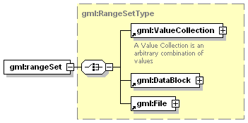
namespace | http://www.opengis.net/gml
type | gml:RangeSetType
children | gml:ValueCollection gml:DataBlock gml:File
used by
  complexTypes | gml:AbstractCoverageType gml:GridCoverageType gml:MultiPointCoverageType gml:MultiSurfaceCoverageType gml:RectifiedGridCoverageType

element gml:RectifiedGridCoverage
diagram | 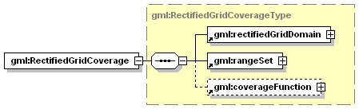
namespace | http://www.opengis.net/gml
type | gml:RectifiedGridCoverageType
children | gml:rectifiedGridDomain gml:rangeSet gml:coverageFunction
attributes
  Name | Type | Use | Default | Fixed | Annotation
  gml:id | ID | optional
  fid | string
    appInfo | deprecated
    documentation | deprecated in GML version 3.0
  dimension | positiveInteger | required

element gml:rectifiedGridDomain
diagram | 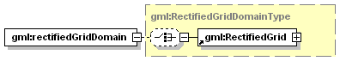
namespace | http://www.opengis.net/gml
type | gml:RectifiedGridDomainType
children | gml:RectifiedGrid
used by
  complexType | gml:RectifiedGridCoverageType
attributes
  Name | Type | Use | Default | Fixed | Annotation
  type | string |  |  | simple
  xlink:href | anyURI | optional
  xlink:role | anyURI | optional
  xlink:arcrole | anyURI | optional
  xlink:title | string | optional
  xlink:show | string | optional
  xlink:actuate | string | optional
  gml:remoteSchema | anyURI | optional

element gml:tupleList
diagram
namespace | http://www.opengis.net/gml
type | gml:CoordinatesType
used by
  complexType | gml:DataBlockType
attributes
  Name | Type | Use | Default | Fixed | Annotation
  decimal | string |  | .
  cs | string |  | ,
  ts | string |  | &#x20;

coverageGeoCoordSystem schema source
<?xml version="1.0" encoding="UTF-8" ?>
- <!--
edited with XMLSPY v5 rel. 4 U (http://www.xmlspy.com) by Stefano Nativi (UCAR Unidata)
-->
<xsd:schema targetNamespace="http://www.ucar.edu/schemas/netcdf" xmlns:xsd="http://www.w3.org/2001/XMLSchema" xmlns:gml="http://www.opengis.net/gml" xmlns:fgdc="http://www.fgdc.gov/metadata/standards" xmlns:nc="http://www.ucar.edu/schemas/netcdf" elementFormDefault="qualified">
<xsd:annotation>
<xsd:documentation>
<appinfo source="urn:ncML:specification:schema-xsd:CoverageGeoCoordSystem:v0.3.1">coverageGeoCoordSystem.xsd</appinfo>
<documentation xml:lang="en">Metadata for coverage associated to a referenced or unreferenced geo coordinate system. An extension to the ncML core metadata in order to formalise netCDF metadata useful for GIS interoperability NcML Group, editor S. Nativi Creation: Boulder, Aug 2003; Update: Florence, Dec 2004; Update: Florence, Jan 2005;</documentation>
</xsd:documentation>
</xsd:annotation>
<xsd:import namespace="http://www.ucar.edu/schemas/netcdf" schemaLocation="C:\Nativi\PAPERI\GIM\schemas\GeoCoordinateSystem.xsd" />
<xsd:import namespace="http://www.opengis.net/gml" schemaLocation="C:\Nativi\Geomatics\STANDARDS\OpenGIS\GML NWIP\GML3\gml3.0\base\grids.xsd" />
<xsd:import namespace="http://www.opengis.net/gml" schemaLocation="C:\Nativi\Geomatics\STANDARDS\OpenGIS\GML NWIP\GML3\gml3.0\base\coverage.xsd" />
<!--
===================== Complex Types defined ====================
-->
<xsd:complexType name="_CoverageGeoCoordSystem">
<xsd:annotation>
<xsd:documentation>Coordinate System of a Coverage dataset. Dataset coordinate system whose domain is characterized by a geographic description. Such geographic description of the domain is generally useful for catalog service. Coverage dataset is characterized by Grid implicit geometry.</xsd:documentation>
</xsd:annotation>
<xsd:complexContent>
<xsd:extension base="nc:_GeoCoordinateSystemType">
<xsd:sequence>
<xsd:element ref="nc:variableRef" />
<xsd:element name="gridCoverage" type="nc:_GridCoverageType" minOccurs="0" maxOccurs="unbounded">
<xsd:annotation>
<xsd:documentation>Grid dimensions stem from geo coordinate system axes.</xsd:documentation>
</xsd:annotation>
</xsd:element>
</xsd:sequence>
</xsd:extension>
</xsd:complexContent>
</xsd:complexType>
<xsd:complexType name="_GridCoverageType">
<xsd:annotation>
<xsd:documentation>If geoCS is located, then grid element is sufficient. Otherwise, useful elements are the specialisations: rectified, referenceable and sparse grids.</xsd:documentation>
</xsd:annotation>
<xsd:sequence>
<xsd:element ref="nc:grid" />
<xsd:element ref="nc:rangeInfo" minOccurs="0" />
</xsd:sequence>
</xsd:complexType>
<xsd:complexType name="_CoverageGeoRefCoordSystem">
<xsd:complexContent>
<xsd:extension base="nc:_GeoRefCoordinateSystemType">
<xsd:sequence>
<xsd:annotation>
<xsd:documentation>Whether geoDomainLocation is present, Coverage can be a rectified Grid. On the contrary, the appropriate elements is the generalization: Grid</xsd:documentation>
</xsd:annotation>
<xsd:element ref="nc:variableRef" maxOccurs="unbounded" />
<xsd:element ref="nc:gridCoverage" minOccurs="0" maxOccurs="unbounded" />
</xsd:sequence>
</xsd:extension>
</xsd:complexContent>
</xsd:complexType>
<xsd:complexType name="_RectifiedGridCoverageType">
<xsd:sequence>
<xsd:element ref="nc:rectifiedGrid" />
<xsd:element ref="nc:rangeInfo" minOccurs="0" />
</xsd:sequence>
</xsd:complexType>
<!--
===================== Global Element defined
-->
<xsd:element name="netcdfCoverages" substitutionGroup="nc:netcdf">
<xsd:annotation>
<xsd:documentation>NetCDF dataset containing one or more Coverages</xsd:documentation>
</xsd:annotation>
<xsd:complexType>
<xsd:complexContent>
<xsd:extension base="nc:NetcdfType">
<xsd:sequence>
<xsd:element ref="nc:coverageGeoCoordSystem" maxOccurs="unbounded" />
</xsd:sequence>
</xsd:extension>
</xsd:complexContent>
</xsd:complexType>
</xsd:element>
<xsd:element name="coverageGeoCoordSystem" type="nc:_CoverageGeoCoordSystem" substitutionGroup="nc:geoCoordinateSystem">
<xsd:annotation>
<xsd:documentation>Extent and geometry information which characterizes the Coverage coordinate system</xsd:documentation>
</xsd:annotation>
</xsd:element>
<xsd:element name="coverageGeoRefCoordSystem" type="nc:_CoverageGeoRefCoordSystem" substitutionGroup="nc:coverageGeoCoordSystem">
<xsd:annotation>
<xsd:documentation>Extent, referenced location and geometry information which characterizes the Coverage coordinate system</xsd:documentation>
</xsd:annotation>
</xsd:element>
<xsd:element name="rectifiedGridCoverage" type="nc:_RectifiedGridCoverageType" substitutionGroup="nc:gridCoverage" />
<xsd:element name="gridCoverage" type="nc:_GridCoverageType">
<xsd:annotation>
<xsd:documentation>Grid dimensions stem from geo coordinate system axes. Grid extent depends on dataset dimensions.</xsd:documentation>
</xsd:annotation>
</xsd:element>
<xsd:element name="rangeInfo">
<xsd:complexType>
<xsd:sequence>
<xsd:element name="rangeSet" type="gml:RangeSetType" />
<xsd:element name="coverageFunction" type="gml:CoverageFunctionType" minOccurs="0" />
</xsd:sequence>
</xsd:complexType>
</xsd:element>
<xsd:element name="variableRef">
<xsd:annotation>
<xsd:documentation>Reference to netCDF variables whose values are the coverage matrix counts</xsd:documentation>
</xsd:annotation>
<xsd:complexType>
<xsd:attribute name="ref" type="xsd:string" />
</xsd:complexType>
</xsd:element>
<!--
===================== GML based elements =============
-->
<xsd:element name="grid" type="gml:GridType">
<xsd:annotation>
<xsd:documentation>Coverage geometry information: describes the matrix dimension axes. These axes are pointed by the CoordianteAxisRef elements</xsd:documentation>
</xsd:annotation>
</xsd:element>
<xsd:element name="rectifiedGrid" type="gml:RectifiedGridType" />
</xsd:schema>

References
- Caron. J., “NetCDF Java Library”, Unidata netCDF packages, available at http://www.unidata.ucar.edu/packages/netcdf-java/
- ISO 19107, “Geographic information — Spatial schema”, Reference number ISO 19107:2003(E), 2003.
- ISO/DIS 19108, “Geographic information — Temporal schema”, document N1001, 12 Oct 2000.
- ISO 19111, “Geographic information — Spatial Referencing by Coordinates”, Reference number ISO 19111:2003(E), 2003.
- ISO 19115, “Geographic information — Metadata” Reference number ISO 19115:2003(E), 2003.
- ISO 19115, “Extensions to ISO/TC 211 – 19115.3 Metadata to support Imagery and Gridded Data”, Document N233, 4 Aug 2000
- ISO 19123, “Schema for coverage geometry and functions”, document N1038, 18 Jan 2001
- S. Nativi, J. Caron, E. Davis and B. Domenico, “Design and implementation of netCDF Markup Language (NcML) and Its GML-based extension (NcML-GML)”, to be published on the Computers & Geosciences Journal, Elsevier Publication, for the Special Issue on the “Applications of XML in Geosciences”.
- Nativi, S., Blumenthal, B., Habermann, T., Hertzmann, D., Raskin, R., Caron, J., Domenico, B., Ho, Y., Weber, J., 2004. Differences among the data models used by the Geographic Information Systems and Atmospheric Science communities, Proceedings of American Meteorological Society – 20th Interactive Image Processing Systems Conference, Seattle (WA), Jan 2004.
- Open GIS Consortium Inc. “Abstract Specification - Topic6: The Coverage Type and its Subtypes ver. 4”, Document 99-106, 31 Mar 1999.
- Open GIS Consortium Inc. “Web Coverage Service (WCS), Version 1.0.0”, Document OGC 03-065r6, Aug 2003.
- Open GIS Consortium Inc. “Web Map Service Implementation Specification ver. 1.1.1”, Document OGC 01-068r3, 11 Jul 2002.
- Open GIS Consortium Inc. “OpenGIS® Geography Markup Language (GML) Implementation Specification version 3.0”, Document OGC 02 023r4, 29 Jan 2003.
- Unidata netCDF Group, “netCDF Usage”, Unidata software: netCDF, available at http://my.unidata.ucar.edu/content/software/netcdf/usage.html
- Unidata netCDF Group, “NetCDF Frequently asked questions”, Unidata software: netCDF, http://available at http://my.unidata.ucar.edu/content/software/netcdf/faq.html#whatisit
- NcML Specification Group, “NcML Overview”, Unidata NcML tutorial, available at www.unidata.ucar.edu/packages/netcdf/ncml/
- Unidata netCDF Group, “NetCDF Description Language”, Unidata software: netCDF, available at http://www.unidata.ucar.edu/packages/netcdf/guidec/guidec-15.html#HEADING15-0
- Unidata netCDF Group, “netCDF Conventions”, netCDF User's Guide, available at http://www.unidata.ucar.edu/packages/netcdf/conventions.html

